**Install Maven**

<https://maven.apache.org/download.cgi>

**Set Environment Variable (System)**

path=<bin location of Maven>

Open CMD and check -> mvn -version

Create MVN project (maven-apache-webapp)

mvn archetype:generate -DgroupId=com.klu -DartifactId=myproject -DarchetypeArtifactId=maven-archetype-webapp -DinteractiveMode=false

**Built-in Lifecycle Bindings**

Some phases have goals bound to them by default. And for the default lifecycle, these bindings depend on the packaging value. Here are some of the goal-to-build-phase bindings.

**Clean Lifecycle Bindings**

|  |  |
| --- | --- |
| **Phase** | **plugin:goal** |
| clean | clean:clean |

**Default Lifecycle Bindings - Packaging maven-plugin**

|  |  |
| --- | --- |
| **Phase** | **plugin:goal** |
| generate-resources | plugin:descriptor |
| process-resources | resources:resources |
| compile | compiler:compile |
| process-test-resources | resources:testResources |
| test-compile | compiler:testCompile |
| test | surefire:test |
| package | jar:jar *and* plugin:addPluginArtifactMetadata |
| install | install:install |
| deploy | deploy:deploy |

**Site Lifecycle Bindings**

|  |  |
| --- | --- |
| **Phase** | **plugin:goal** |
| site | site:site |
| site-deploy | site:deploy |

**phases and goals and plugins**

**A Build Phase is Made Up of**[**Plugin**](https://maven.apache.org/plugins/index.html)**Goals**

Most of Maven's functionality is in plugins. A plugin provides a set of **goals** that can be executed using the following syntax:

mvn [plugin-name]:[goal-name]

For example, a Java project can be compiled with the compiler-plugin's compile-goal by running mvn compiler:compile

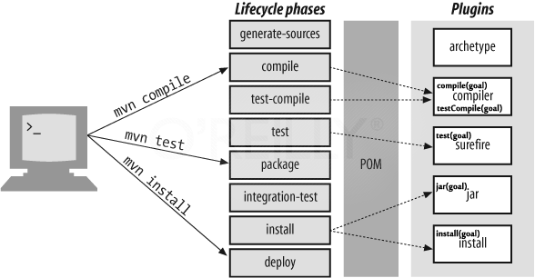

**Pom.xml – Editing**

<properties>

<java.home>C:/Program Files/Java/jdk-17.0.1/bin/javac</java.home>

</properties>

<build>

<plugins>

<plugin>

<groupId>org.apache.maven.plugins</groupId>

<artifactId>maven-compiler-plugin</artifactId>

<version>3.5.1</version>

<configuration>

<verbose>true</verbose>

<fork>true</fork>

<executable>${java.home}</executable>

<compilerVersion>1.8</compilerVersion>

<source>1.8</source>

<target>1.8</target>

</configuration>

</plugin>

<plugin>

<groupId>org.apache.tomcat.maven</groupId>

<artifactId>tomcat7-maven-plugin</artifactId>

<version>2.2</version>

<configuration>

<port>9090</port>

<path>/</path>

</configuration>

</plugin>

</plugins>

</build>

**Executing Quickstart Project**

mvn exec:java -Dexec.mainClass=com.klu.App

**Executing Webapp Project**

mvn tomcat7:run

**Documentation of Website**

<build>

<plugins>

<plugin>

group - org.apache.maven.plugins

artifact - maven-site-plugin

verion - 3.7.1

group - org.apache.maven.plugins

artifact - maven-surefire-plugin

version - 3.0.0-M3

<reporting>

<plugins>

<plugin>

group - org.apache.maven.plugins

artifact - maven-surefire-report-plugin

version - 3.0.0-M3

mvn clean package site

cd target/site

open index.html